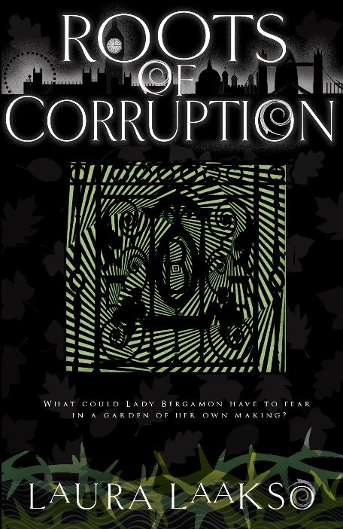
Roots of Corruption
by Laura Laakso
26th March 2020

“What could Lady Bergamon have to fear in a garden of her own making?”

On the night of Samhain, the veil between worlds is at its thinnest, and ancient magic runs wild in Old London.

When Lady Bergamon is attacked in her Ivy Street garden, Wishearth turns to Yannia for help. Who could have the power to harm Lady Bergamon in her own domain? While Yannia searches for the answer, nature herself appears to be killing Mages in Old London. Yannia and Karrion join forces with New Scotland Yard to solve the baffling Mage deaths. But wherever they turn, all the clues point back towards Ivy Street.

Yannia's abilities are put to test as she races to save Lady Bergamon’s life, and prevent further murders. But with the lines between friends and enemies blurring, she must decide who to trust and how much she's willing to sacrifice for Old London and its inhabitants…

Laura Laakso is a Finn who has lived for most of her adult life in England. She is an accountant, dog trainer and author. Roots of Corruption is the follow up to Fallible Justice and Echo Murder, and the third novel in her paranormal crime series Wilde Investigations.

£8.99
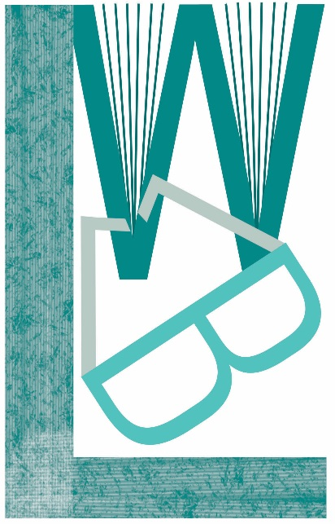
ISBN 9781999630515

Also in e-book and audio

Available from Louise Walters Books, Gardners and Bertrams

BIC category: FM – Fantasy

Paperback “B” format, 384 pp

All enquiries info@louisewaltersbooks.co.uk

Louise Walters Ltd, PO Box 755, Banbury, OX16 6PJ

#RootsofCorruption #FallibleJustice #EchoMurder

@LLaaksoWriter @LouiseWalters12

