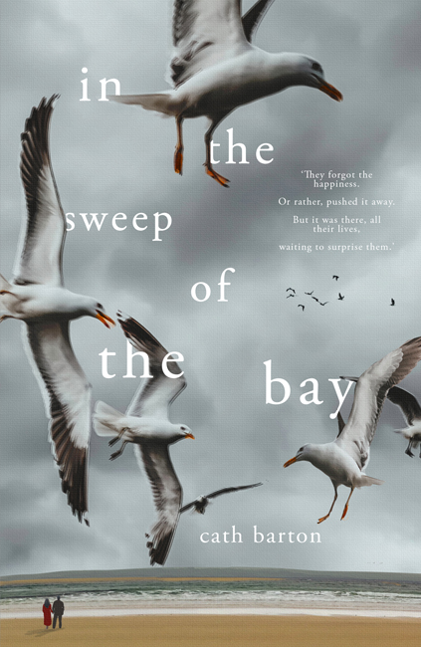
In the Sweep of the Bay
by Cath Barton
17th September 2020

‘They forgot the happiness.
Or rather, pushed it away.
But it was there, all their lives,
waiting to surprise them.’

This lyrical, warm-hearted tale explores marriage, love, and longing, set against the majestic backdrop of Morecambe Bay, the Lakeland Fells, and the faded splendour of the Midland Hotel.

Ted Marshall meets Rene in the dancehalls of Morecambe and they marry during the frail optimism of the 1950s. They adopt the roles expected of man and wife at the time: he the breadwinner at the family ceramics firm, and she the loyal housewife, but as the years go by, they both find themselves wishing for more…

After Ted survives a heart attack, both see it as a new beginning… but can a faded love like theirs ever be rekindled?

Cath Barton lives in Abergavenny. She won the New Welsh Writing AmeriCymru Prize for the Novella in 2017 for The Plankton Collector, which was published in September 2018 by New Welsh Review under their Rarebyte imprint. She also writes short stories and flash fiction and, with her critical writing, is a regular contributor to Wales Arts Review. In the Sweep of the Bay is her second novella.

£7.99

ISBN 9781999630577
Paperback and e-book

Available from Louise Walters Books, Gardners and Bertrams

BIC category: FA – Modern and contemporary fiction

Paperback “B” format, 144pp

All enquiries info@louisewaltersbooks.co.uk

Louise Walters Ltd, PO Box 755, Banbury, OX16 6PJ

In the #SweepoftheBay @CathBarton1 @LouiseWalters12

